HILL CIPHER

* PROBLEM STATEMENT
  + To encrypt a given plaintext to Hill cipher with key.
  + Decrypt the given Hill Cipher with key .
* ENCRYPTION
  + The plain text and the key are passed as inputs to the Encryptor function.
  + Each letter is represented by a number modulo 26(Ex:A=0,B=1).
  + The key can be written as nxn matrix. Similarly, the plain text is written as a vector and these two matrices are multiplied using matmul function. The values in resultant matrix are are reduced to modulo 26 and replaced with respective alphabets. This is the required encrypted text.

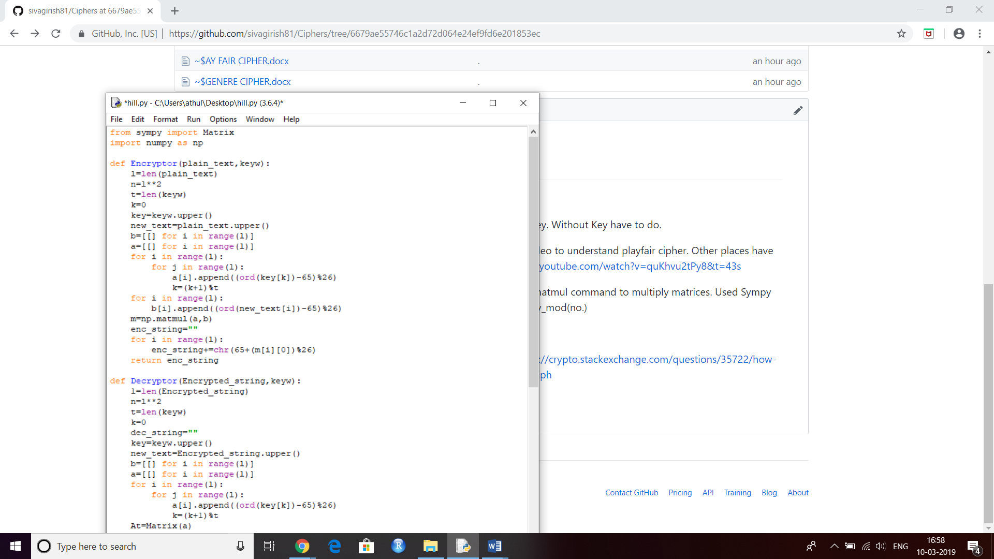

DECRYPTION

* + Decryption is performed by calculating the inverse of key matrix and then multiplying it with the vector of encrypted text.
  + The values in resultant vector is reduced to its modulo 26 and replaced with respective alphabets.
  + This is the required decrypted text.

